
H
CATHOLIC JUNIOR COLLEGE
Preliminary Examination 2010
Higher 2

CHEMISTRY 9647

Paper 1 Multiple Choice 17 September 2010

1 hr

Additional Materials: Multiple Choice Answer Sheet
Data Booklet

READ THESE INSTRUCTIONS FIRST

Write in soft pencil.
Do not use staples, paper clips, highlighters, glue or correction fluid.
Write your name, class and NRIC on the Answer Sheet in the spaces provided.

There are forty questions on this paper. Answer all questions. For each question there are four possible answers A, B, C and D.
Choose the one you consider correct and record your choice in soft pencil on the separate Answer Sheet.

Read the instructions on the Answer Sheet very carefully.

Each correct answer will score one mark. A mark will not be deducted for a wrong answer.

Any rough working should be done in this booklet.

This document consists of 15 printed pages and 1 blank page.



CJC Chemistry Department

© CJC 2010
For each question there are four possible answers, A, B, C and D. Choose the one you consider to be correct and record your choice in soft pencil on the separate answer sheet provided.

- Bromine gas is toxic to human health. The maximum safe tolerance level of bromine gas in air is 0.004 mg dm⁻³.

How many bromine atoms are present in 1 dm³ of air at this tolerance level?

A 1.50 x 10¹⁶ C 6.00 x 10¹⁶
B 3.00 x 10¹⁶ D 3.00 x 10¹⁹

2 20.0 cm³ of 0.02 mol dm⁻³ aqueous sodium bromate(V), NaBrO₃, was found to react completely with 60.0 cm³ hydroxylamine, NH₂OH of equal concentration. The half equation for the reduction of bromate(V) ion is given as shown.

BrO₃⁻(aq) + 6H⁺(aq) + 6e⁻ → Br⁻(aq) + 3H₂O(l)

Which of the following could be the nitrogen-containing product in this reaction?

A NO B NO₂ C N₂O D NO₃⁻

3 Which of the following concerning 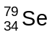 and 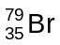 is true?
A has a smaller atomic size than .
B has more protons per atom than .
C has more neutrons per atom than .
D Both and contain the same number of electrons per atom.

4 What is the electronic configuration of an element with a second ionisation energy higher than that of each of its neighbours in the Periodic Table?

A 1s² 2s² 2p⁶ 3s² C 1s² 2s² 2p⁶ 3s² 3p²
B 1s² 2s² 2p⁶ 3s² 3p¹ D 1s² 2s² 2p⁶ 3s² 3p³

5 The melting point of 4-nitrophenol is higher than that of 2-nitrophenol.

Which statement best explains the above observation?

A 4-nitrophenol has a closer packing in the solid state.
B 2-nitrophenol has less surface area for hydrogen bonding.
C The strength of hydrogen bonding is stronger in 4-nitrophenol.
D The extent of intermolecular hydrogen bonding is less in 2-nitrophenol.

6 The characteristic smell of garlic is due to alliin. When garlic is cut, an enzyme releases alliin because alliin has the right shape to fit the enzyme molecule.
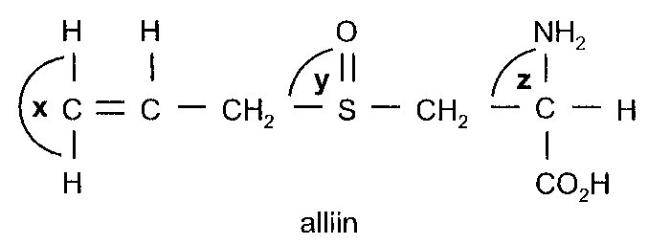

What would you expect the bond angles x, y and z to be (to the nearest 10°) in a molecule of alliin?

 | x | y | z
A | 120° | 110° | 110°
B | 120° | 120° | 110°
C | 180° | 90° | 90°
D | 180° | 110° | 110°

7 Which graph best represents the behaviour of an ideal gas at constant temperature, where the number of moles of gas in containers A and B are 2 and 1 respectively?
(ρ refers to the density of the gas)
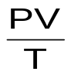
P
ρ
A
B
V
A
B
A |  | C
B | V  A  B  P | D | 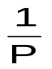  V  A  B

8 Magnesium readily reacts with bromine to form MgBr₂ instead of MgBr.
Which statement best explains this observation?

- More energy is required to form MgBr₂(s) than MgBr(s) from its elements.
- Less energy is required for the ionisation of Mg to Mg²⁺ as compared to ionisation of Mg to Mg⁺.
- More energy is released from the formation of MgBr₂(s) than MgBr(s) from its gaseous ions.
- Less energy is released in forming Br ⁻ from Br₂ in the formation of MgBr₂(s) than in the formation of MgBr(s).

9 The diagram below represents the Boltzmann distribution of molecular energies of a reaction mixture at a given temperature.
energy, E
Number of molecules with energy, E
activation energy
C
D
A
B

Which of the following change will occur when a catalyst is added to the reaction mixture?

- The peak of the graph will shift in the direction of A.
- The peak of the graph will shift in the direction of B.
- The activation energy will shift in the direction of C.
- The activation energy will shift in the direction of D.

10 The mechanism for a certain reaction is given below:
2A C (fast)
C + B → D (slow)
D + B → A₂B₂ (fast)
What conclusion can be drawn from the above mechanism?

- The rate equation is rate = k[C][B].
- The units of the rate constant, k, is mol⁻² dm⁶ s⁻¹.
- The reaction is first order with respect to D.
- The overall equation is 2A + 2B + C + D → A₂B₂.

11 A and B₂ react according to the following equation:

2A(g) + B₂(g) A₂B(g) + B(g)

When 0.6 mol of A is mixed with 0.3 mol of B₂ at 298 K in a 2 dm³ vessel, it was found that one-third of A had been converted to products at equilibrium.

What is the numerical value of K_{c} for the reaction at 298 K?

A 0.625 B 0.556 C 0.313 D 0.125

12 The pH change during a titration when a monobasic acid is added dropwise to 20.0 cm³ of NaOH is shown below.
12

10

7

4

Volume of acid added/cm³

10 203040
pH

Which statement about the titration is correct?

A Both an acidic and basic buffer can be formed at different points during this titration.
B Both phenolphthalein and methyl orange can be used as an indicator for this titration.
C Ethanoic acid is used in this titration and it has a pK_{a} value of less than 4.
D Benzoic acid is used in this titration and it has a similar concentration as NaOH.

13 Which statement is an incorrect description of a buffer solution?

A It must contain an equal amount of weak acid and its conjugate base.
B It may contain an amino acid.
C It resists pH change on slight dilution.
D It cannot resist pH change when large amount of acid is added.

14 Use of the Data Booklet is relevant to this question.

When a large current was passed through acidified aqueous copper(II) sulfate, there was simultaneous liberation, at the cathode, of x mol of copper and y dm³ of hydrogen gas (measured at s.t.p.).

How many moles of electrons were passed through the solution?

A 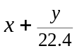 B 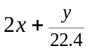 C 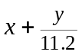 D 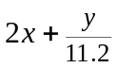

15 Use of the Data Booklet is relevant to this question.

A new type of rechargeable battery which uses vanadium salts is hailed as a possible battery for electric cars. This is a flow battery in which the electrolytes are stored in tanks and pumped through the cell during discharge. A diagram of the battery is shown below.
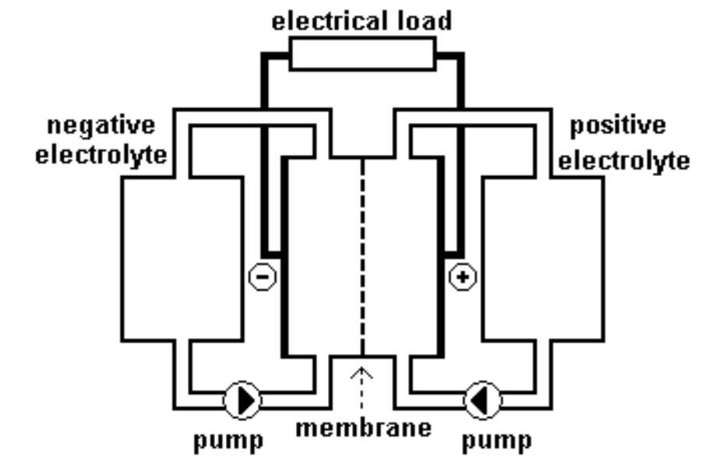
Tank P:
Electrolyte containing acidic aqueous solution of sulfate salts of VO₂⁺ and VO²⁺
Tank Q:
Electrolyte containing acidic aqueous solution of sulfate salts of V³⁺ and V²⁺
Electrode P
Electrode Q

Which statement is correct?

A Reduction occurs at Electrode P.
B Electrode P is the anode.
C Porous carbon electrodes are used to increase the total surface area of the electrodes so as to increase the E^{ө}_{cell}.
D The membrane allows electrons to pass through to maintain electrical neutrality.

16 X, Y and Z are consecutive elements in Period 3 of the Periodic Table. Element Y has the highest first ionisation energy and the lowest melting point.

What could be the identities of X, Y and Z?

A sodium, magnesium, aluminium C aluminium, silicon, phosphorus
B magnesium, aluminium, silicon D silicon, phosphorus, sulfur

17 0.2 mol of a compound reacts with cold water to form 0.4 mol of HCl. In hot water, 1.0 mol of HCl is formed instead. The melting point of the compound is 167 ºC.

Which of the following is likely to be the compound?

A NaCl B MgCl₂ C PCl₅ D SiCl₄

18 Photographic film contains silver halides, which absorb light to undergo a ‘self-redox’ process whereby silver metal and halogens are formed. Different silver halides have different sensitivity to light and will undergo this process to a different extent.

During the development of the film, a solution of aqueous ammonia or sodium thiosulfate is used to dissolve the unreacted silver halides. However, sodium thiosulfate is preferred, as some silver halides are not soluble in aqueous ammonia.

Which statement concerning the above processes is correct?

A Silver metal forms a very stable complex with thiosulfate, hence silver halides are soluble.
B AgCl is more soluble than AgBr in aqueous ammonia, as solubility product of AgCl is of a lower value.
C AgI can undergo ‘self-redox’ to a larger extent as iodide is more readily oxidised.
D AgBr is preferred to be used, as the bromine formed is less reactive than iodine.

19 A chromium compound dissolves in water to give a green solution E which undergoes the following reactions.

E
green solution
F
purple solution
NH₃(aq)
G
yellow solution
H₂O₂(aq)

H⁺(aq)

H
orange solution

What can be deduced from the above observations?

A The reaction of E to form F is a ligand displacement reaction.
B The oxidation state of chromium in E is higher than that in H.
C The chromium-containing ion in yellow solution G is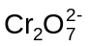.
D The chromium-containing ion in orange solution H is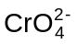.

20 In what way is propene similar to propane?

A Both can be obtained by the dehydration of alcohols.
B Both can react with chlorine under suitable conditions.
C Both can be hydrogenated using a suitable catalyst.
D Both can undergo polymerisation under suitable conditions.
- Some chlorobutanes were separately treated with hot ethanolic sodium hydroxide. Two of these gave the same hydrocarbon, C₄H₆.

From which pair of chlorobutanes was this hydrocarbon obtained?

A CH₃CH₂CH₂CH₂Cl and CH₃CH₂CCl₂CH₃
B CH₃CH₂CH₂CH₂Cl and ClCH₂CH₂CH₂CH₂Cl
C CH₃CHClCHClCH₃ and ClCH₂CH₂CH₂CH₂Cl
D CH₃CH₂CH₂CH₂Cl and CH₃CH₂CH₂CHCl₂

- The following shows the time taken for appearance of precipitate after adding aqueous AgNO₃ to four halogen derivatives separately.
Halogen Derivative | Time for precipitate to appear
Chlorobenzene | No precipitate
2-chlorobutane | 10 minutes
2-bromobutane | 2 minutes
2-iodobutane | Instantaneous

Which of the following would be the best explanation for the observation?

      - The lattice energy becomes more exothermic from AgCl to AgI.
      - The ease of electron cloud distortion decreases from chlorobenzene to
2-iodobutane.
C The carbon-halogen bond strength decreases from chlorobenzene to 2-iodobutane.
D The carbon-halogen bond length decreases from 2-chlorobutane to 2-iodobutane.

23 Tyrosol is a naturally occurring oxidant found in olive oil.

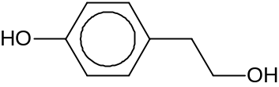
Tyrosol

Which statement about Tyrosol is incorrect?

A 1 mol of Tyrosol will react with 2 mol of Na to give 1 mol of H₂.
B 1 mol of Tyrosol will react with 2 mol of PCl₅ to give 2 mol of HCl.
C Tyrosol will react with acidified KMnO₄ under reflux to give a carboxylic acid.
D Tyrosol will react with H₂SO₄ under suitable conditions to give an alkene.

24 Catechin is an antioxidant found in tea leaves, chocolates and red wine. It is often studied for its function as an inhibitor to the growth of cancer cells among other health benefits.

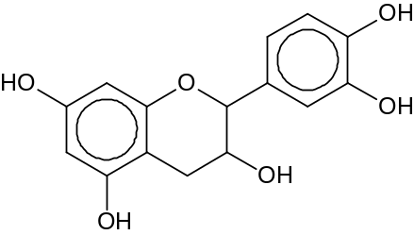
Catechin
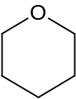 ring is not involved in any of the following reactions.

Which statement about catechin is correct?

A It can undergo oxidation with hot acidified K₂Cr₂O₇.
B It can undergo electrophilic addition with Br₂(aq).
C 1 mol of catechin can react with 5 mol of NaOH.
D 1 mol of catechin can react with 4 mol of Na₂CO₃.

25 In which reaction does the organic reactant have a bond angle that is larger than the carbon-containing product?

A complete combustion of ethene in air
B heating methanal with LiAlH₄ in dry ether
C mixing methane with chlorine gas in the presence of UV light
D heating bromoethane under reflux with alcoholic potassium hydroxide

26 Which of the following about the amino acid, methionine, is true?

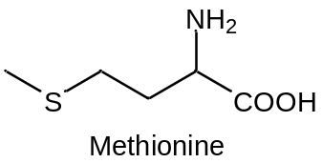

A It acts as a buffer in a solution of pH 13.
B It exists predominantly as a zwitterion in a solution of pH 2.
C It exists as a crystalline solid with high melting point.
D It forms covalent disulfide linkage with another methionine molecule.

27 Compound X undergoes oxidative cleavage with hot acidified KMnO₄ to give a single organic product.

The organic product formed gives a yellow precipitate when heated with aqueous alkaline iodine, but does not react with sodium carbonate.

Which could be the identity of Compound X?

A | 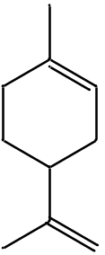 | B | 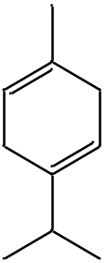 | C | 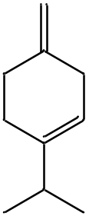 | D | 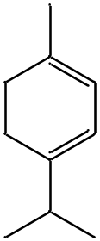

28 The carbon-nitrogen bond length in methylamine is longer than that in formamide.

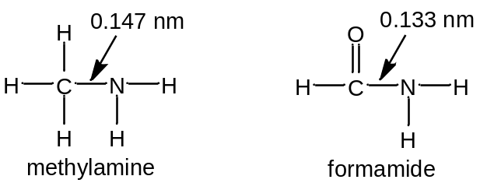

What helps to explain the shorter carbon-nitrogen bond length in formamide?

A It is an sp²-sp² overlap.
B Formamide is a weaker base than methylamine.
C The electrons in the filled p orbitals on C and N of methylamine repel each other.
D The electron withdrawing C=O group in formamide draws the lone pair of electrons on N closer to itself.

29 Hydrocortisone is a steroid hormone produced by the adrenal gland and is released in response to stress. It is commonly used as an active ingredient in anti-inflammatory creams.
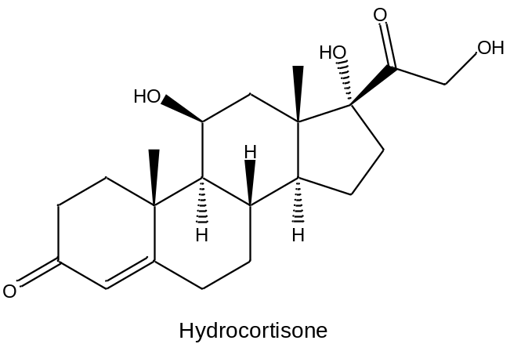

Which of the following statements about hydrocortisone is true?

A When treated with NaBH₄ in the presence of methanol, it forms a compound containing 5 hydroxy groups.
B When warmed with aqueous alkaline iodine, a yellow precipitate is observed.
C When treated with cold dilute KMnO₄, it forms a compound containing 2 hydroxy groups.
D When treated with an excess of hot concentrated acidified KMnO₄, it forms a compound containing 7 chiral centres.

30 Loviride was once used as an antiviral drug in clinical trials and is structurally similar to Compound Z.
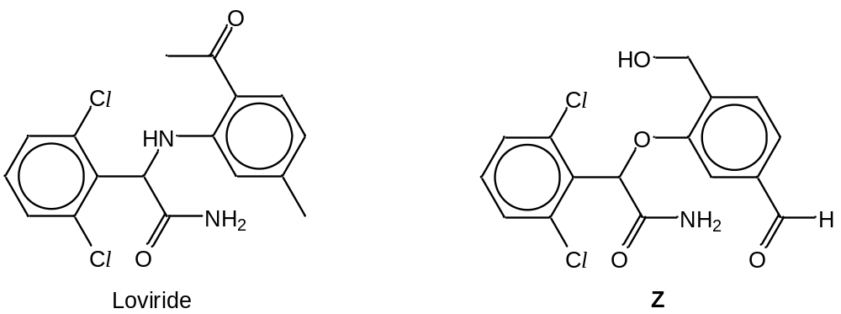

Which reagent could be used to distinguish Loviride from Compound Z?

A aqueous alkaline iodine C aqueous bromine
B aqueous sodium hydroxide D hot acidified potassium manganate(VII)
For each of the following questions, one or more of the three numbered statements 1 to 3 may be correct. Decide whether each of the statements is or is not correct. The responses A to D should be selected on the basis of:
A | B | C | D
1, 2 and 3 are correct | 1 and 2 only are correct | 2 and 3 only are correct | 1 only is correct

31 Which of the pairs contain a giant ionic compound and a simple molecular compound?

1 Al₂O₃ and Al₂Cl₆
2 SiO₂ and SiCl₄
3 P₄O₁₀ and PCl₃

32 The compound sodium borohydride, NaBH₄, is commonly used as a source of the hydride anion for synthetic purposes.
Which types of bonding are found in the compound?

1 ionic
2 covalent
3 hydrogen bonding

33 Which equations represent the standard enthalpy change of reaction?

1 C₂H₆(g) + O₂(g) → 2CO₂(g) + 3H₂O(l)
2 Fe(s) + O₂(g) + H₂(g) → Fe(OH)₃(s)
3 3C(s) + 3H₂(g) → CH₂=CHCH₃(g)

34 The diagram below shows the reaction pathway of one of the mechanisms in the reaction of halogenoalkanes with aqueous potassium hydroxide.

Energy
Y

X

Reaction pathway

What information could be deduced from the above diagram?

1 X represents the carbocation intermediate formed in the reaction.
2 Y represents the transition state of the rate determining step.
3 The diagram shows a two-step mechanism of a S_{N}2 reaction.

35 A student set up 4 standard half-cells each containing one of the metals, W, X, Y, Z, immersed in a solution of its metallic salts. These were then used to make different electrochemical cells. The table below shows the standard electrode cell potential, E^{ө}_{cell} and the positive terminal of each electrochemical cell.

Cell | Metals used | E^{ө}_{cell} / V | Positive terminal
1  2  3 | W and X  X and Y  X and Z | +1.10  +0.46  +0.47 | X  Y  X

Which of the following statements are true?

1 Y is produced in Cell 2.
2 Z has a stronger reducing power than Y.
3 W can reduce all the cations of X, Y and Z.

36 A student tried to prepare solutions of group II metal ions, M²⁺.

Barium oxide and magnesium oxide were dissolved in two beakers of sulfuric acid separately. The metal oxide to acid ratio was 1:1. In one of the solutions, a white precipitate was formed. In the other solution, no precipitate was observed and the solution was weakly acidic.

Which statements correctly explain the above observations?

1 Barium sulfate is less soluble than magnesium sulfate as the hydration energy of barium ions has a smaller magnitude than that of magnesium ions.
2 The charge density of magnesium ions is greater than that of barium ions, hence it can undergo hydrolysis to give a weakly acidic solution.
3 Barium sulfate has a smaller solubility product compared to magnesium sulfate.

37 In an aldol condensation, an aldehyde loses its α hydrogen atom when a base is added. The intermediate then undergoes nucleophilic addition with another aldehyde molecule. When alcoholic potassium hydroxide is added to ethanal, the following reaction occurs:

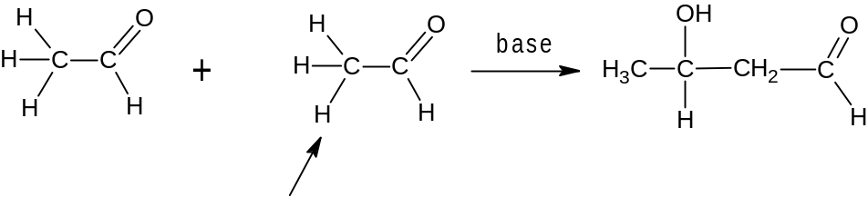
α hydrogen atom

What are the possible products when alcoholic potassium hydroxide is added to an equimolar mixture of ethanal and propanal?

1 CH₃CH(OH)CH₂CHO
2 CH₃CH₂CH(OH)CH₂CHO
3 CH₃CH₂CH(OH)CH(CH₃)CHO

38 Methylparaben is used as both a food preservative and a anti-fungal agent in cosmetics.

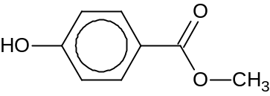
methylparaben

Which of the statements about methylparaben are correct?

1 It is likely to be more acidic than phenol.
2 It can react with ethanoyl chloride to form an ester.
3 It can react with 2,4-dinitrophenylhydrazine to give an orange precipitate.

39 Fluocortin is a glucocorticoid that is involved in the regulation of glucose metabolism.

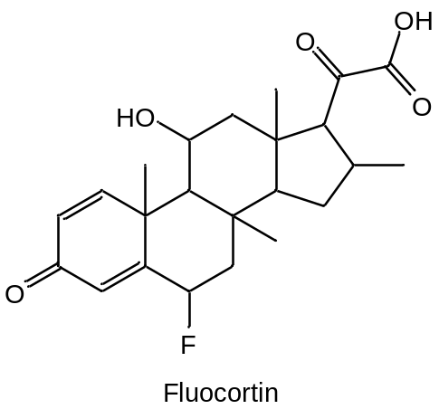

Fluocortin is first reacted with hydrogen in the presence of a platinum catalyst to obtain a Compound Y.

Which of the statements concerning Compound Y are true?

1 Oxidation of Y produces an organic compound that reacts completely with 3 mol of 2,4-dinitrophenylhydrazine.
- It has three chiral centres more than Fluocortin.
- It can be distinguished from Fluocortin by using sodium carbonate.

- Deuterium, D, is the ²H isotope of hydrogen.

Which of the reactions will give an organic product containing deuterium?

1 | 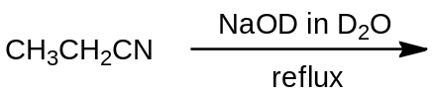
2 | 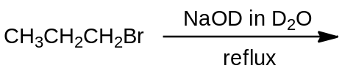
3 | 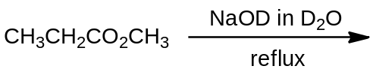

END OF PAPER

